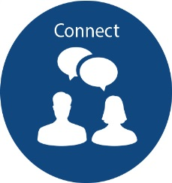
Connect with the people around you. We are all in this together. Keep in touch with family, friends, colleagues or neighbours through calls, text or video links like FaceTime, WhatsApp, Messenger or Skype. Arrange a daily telephone call, especially with those who may be at home alone.
Be
Website | Description of Activity
https://www.macmillan.org.uk/get-involved/campaigns/telephone-buddies | Macmillan telephone buddies - Friendly phone calls
https://www.ageuk.org.uk/northern-ireland/ | Check in and chat, befriending.
Cancer Choices NI - Seamus: 07843 478433 | Befriending
www.Aware-ni.org | Mental health charity based in NI advice and support to help reduce feelings of anxiety and isolation
https://www.amh.org.uk/news/amh-menssana-on-line/ | Action Mental Health - on-line support courses for young people
https://www.cancerresearchuk.org/about-cancer/cancer-chat/home | Cancer Research UK Cancer Chat-online forum
Good Morning/Good Neighbour Newry and Mourne http://www.ccgnewrycommunity.org/good_morninggood_neighbour_service | Good Morning is a confidential telephone service for older people who are feeling isolated, vulnerable and lonely. The service offers a daily or weekly telephone call from a volunteer for friendly chat and advice on other support services.
Good Morning Neighbour (ABC council area)- http://www.youcanhelp.org | Good Morning phone calls 365 days a year, befriending visitation service to home and or place of residence, door step deliveries for basic foods, medicine, coal, gas and other necessities. Nuisance call blockers, advice and support on doorstep, telephone and online scams.
https://www.communityni.org/ | Many organisations want to help in response to the many challenges facing people, communities, and our health and care services. NICVA has developed this service to allow organisations to easily add their services to a central database that can be used by all organisations.  Information on the website is provided by users and is not verified, so please report any incorrect or inappropriate listings, and never give personal or financial details online to someone you don't know.

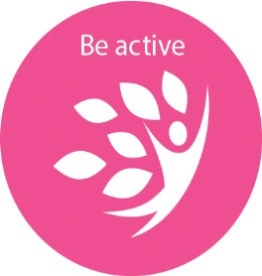
Exercising makes us feel good mentally and physically. We have to be a little creative in our new situation. Gardening or housework count as physical activity. Maybe try an online exercise video. The NHS website has a range of options, or there are a number of fun videos available free on YouTube for all ages and different levels of ability.

Website | Description of Activity
Youtube channel: move more ni,  Also available on Facebook. Contact coordinators on Email: movemore@armaghbanbridgecraigavon.gov.uk movemore@nmandd.org Conor.Fox@midulstercouncil.org. | Macmillan Move More -Online exercise videos, telephone/video one to one consultations
https://apps4healthcareni.orcha.co.uk | Apps4Healthcare - a huge resource of health and wellbeing apps which have been checked for quality. Mental Health, fitness, nutritional and sleep health apps
https://www.armaghbanbridgecraigavon.gov.uk/exercise-relaxation-videos/ | exercise and mindfulness videos on the get active ABC council website
https://www.ageuk.org.uk/information-advice/health-wellbeing/exercise/simple-exercises-inactive-adults/ | Age UK simple exercises to get moving more
https://www.nhs.uk/live-well/exercise/gym-free-workouts/ | exercise videos from the NHS website
http://pha.site/workout | NHS website with a range of online exercise videos

Take Notice - Stop, pause and take a moment to be still and look around you. Reduce your time watching the news and browsing social media. Let go of what none of us can control right now and focus on what you can control. Acknowledge your thoughts and feelings and be kind to yourself. It is normal not to feel ‘normal’ during this time. Listen to gentle music or try relaxation apps and videos. Know that this is temporary and things will get better. Take notice of your habits. Avoid smoking or drugs, and try not to drink too much alcohol. It can be easy to fall into unhealthy patterns of behaviour that end up making you feel worse.

Website | Description
https://ngs.org.uk/ | National garden virtual tours- tour gardens from the national garden scheme online
https://www.britishmuseum.org/collection/galleries#virtual-galleries | Virtual tour of the British museum
https://www.timeout.com/travel/virtual-museum-tours | List of some of the museums that offer virtual tours online.
https://mindfulnessexercises.com/free-online-mindfulness-courses/mindfulness-meditations-for-kids | Mindfulness Meditations for Kids and Adults: Free online meditations
https://www.aware-ni.org/intro-to-mindfulness | Free online mindfulness course offered by Awareni
https://www.publichealth.hscni.net/news/free-online-stress-control-classes-available-monday-13th-april | Public Health Agency stress control classes-Free online classes delivered over the Covid 19 period

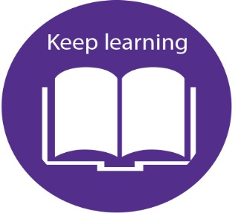
Keep Learning-We are all learning how to do things differently for now; learning new ways of doing things and how to enjoy ourselves. Use this time for some discovery. Learning new things gives us a sense of achievement, increased confidence and enjoyment. Use this as an opportunity to teach your children new skills or maybe sign up to an online course.

Website | Description
https://www.open.edu/openlearn/free-courses/full-catalogue | free online classes on everything from art to learning a new language to business, the courses are run by the open university and can be completed anytime
https://www.moma.org/research-and-learning/classes | - the museum of modern art offers free online courses on various different aspects of modern art and fashion
https://www.youtube.com/watch?v=v4YJzNIBn-w | a video link showing how to create your own prints and turn them into beautiful collage art pieces
https://www.youtube.com/channel/UCQ85xLA2BlQQdrnWBhKw1hw | arts 4 u utube channel which has a number of free online art workshops available
https://www.artyfactory.com | offers free online art and design classes/instruction videos
http://www.bbc.co.uk/learning/subjects/music.shtml | Online learning support and advice, music courses
https://alison.com/courses | Free online courses on a wide variety of topics
https://www.mombooks.com/mom/online-activities/ | Art therapy - Digital activities page from Michael O’Mara Books. online colouring activities, quizzes, and downloadable extras from his books. They also have links to a number of colour therapy apps
joanneboal@cancerfocusni.org | Art journaling with cancer focus every Friday via zoom email for zoom meeting code

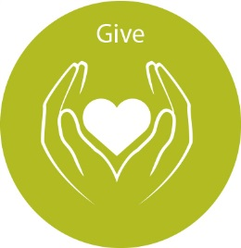
Give- We are all helping our community and our health service by staying at home. This is the greatest gift you can give right now.

Website | Description
https://www.volunteernow.co.uk/ | Volunteering opportunities across NI
https://www.communityni.org/job | Volunteering opportunities across NI
https://www.facebook.com/Craigavon-Banbridge-Volunteer-Bureau-133739080010774/ | Volunteering opportunities in Craigavon and Banbridge
https://volunteering.macmillan.org.uk | Telephone buddy volunteer opportunity
https://www.midulstervolunteercentre.org/ | Volunteering opportunities in the Mid Ulster Area

