

**Want to increase your chances of**

**quitting smoking?**

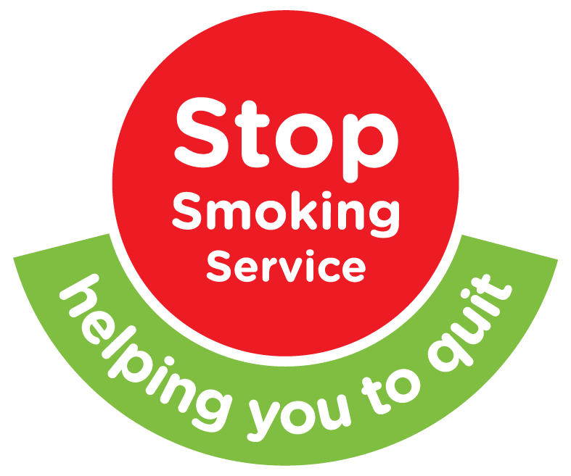

**The free stop smoking**

**service can help you**

You are up to 4 times more likely to quit with our help

* Free Service
* One to one consultation
* Personalized quit plan and advice on how to top smoking
* Contact a clinic near you

**To receive an appointment near you and for 1-1 local support contact the Southern Trust stop smoking service on**

**028 3756 4400**

**Or email [stop.smoking@southerntrust.hscni.net](mailto:stop.smoking@southerntrust.hscni.net)**

**or visit the Southern trust website:** [**http://www.southerntrust.hscni.net/livewell/1576.htm**](http://www.southerntrust.hscni.net/livewell/1576.htm)

