Practices to help us come to terms with grief
Taken from the Booklet Below:
https://www.collectivepsychology.org/wp-content/uploads/2020/04/This-Too-Shall-Pass.pdf

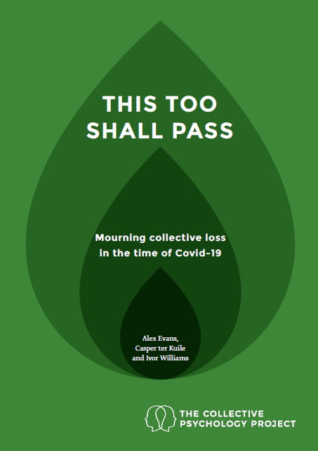

Finally, we offer five practices for grieving well, each of which can be explored
individually or in groups.

• Writing a Grief Letter or Grief List. Making an inventory of what we are
grieving can be enormously helpful when we feel overwhelmed – either in
personal writing or in collective online journaling.
• Making a Grief Altar or Memorial Corner. Creating a special place in
the house or online to make space for grief – a place for photos of places we
cannot go, tickets unused, photos of people we loved who have passed – can
help us to say goodbye.
• A Gratitude Walk. Physical movement can unlock things in us that thinking
alone cannot. Going for walks, alone or with a loved one (whether beside
us or on the phone) while focusing on things we are thankful for can be a
powerful practice for dealing with loss.
• Telling Stories. When someone we love has died, it helps to listen to, and
tell, stories about them, just as we do at a wake – and we can find deep comfort in spaces to remember specific losses in our lives, either with one other person, or in online groups.
• Listening to Music that Helps us Feel. Music can open a pathway to
our emotions in a way that words sometimes cannot, and we can open ourselves up to grief through listening to sad or elegiac music either alone or
with others.

