Managing your Emotional Wellbeing During the Coronavirus Outbreak
An information and resource pack for clients

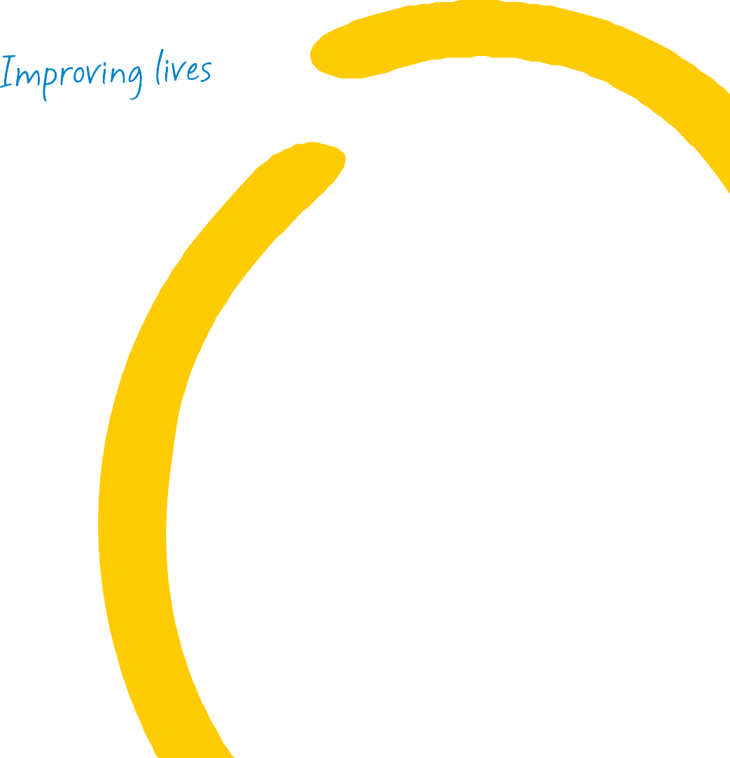
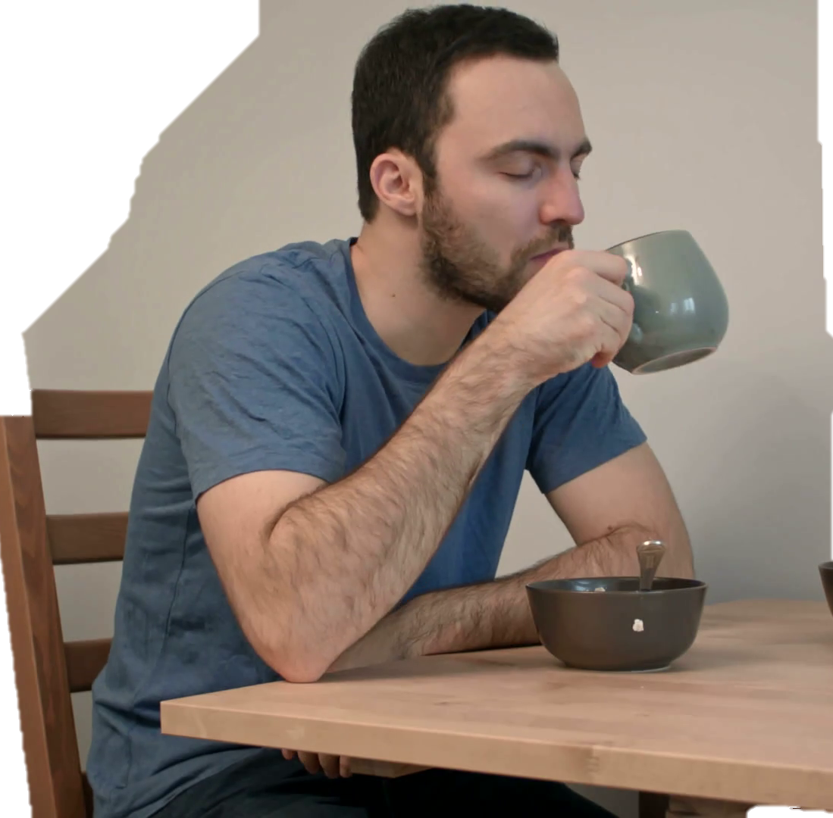
What is the Coronavirus?

We know that the current situation with the Coronavirus is a worrying and difficult time for everyone.

This resource pack has been put together by OPMH Psychologists to provide you with information, and coping strategies to help you manage your emotional wellbeing through what is an uncertain time.

A coronavirus is a type of virus. As a group, coronaviruses are common across the world. This strain, Covid-19 is a new strain identified in January 2020.

What are the symptoms?
- A new and persistent cough
- A high temperature
- Shortness of breath
If you are worried about symptoms, you can call NHS 111 to get advice. You should not go directly to your GP or other healthcare environment. If it is an emergency call 999.

What’s the best way to prevent the spread of covid-19?

- Wash your hands often with soap for 20 seconds or use hand sanitizer.
- Cover your cough or sneeze with a tissue and throw in the bin.
- Clean and disinfect frequently touched objects.
- Avoid touching your eyes, nose and mouth with unwashed hands.

When to stay at home
You should ‘self-isolate’ if:
- You have symptoms (for 7 days)
- If you live with someone who has symptoms (for 14 days)

Limiting social contact
You should reduce your time outside of your home and with others if:
- If you are aged 70 or over
- If you have a long-term health condition
- If you live with someone aged 70 or over, or with someone with a long-term health condition.

Shielding the extremely vulnerable
If you are classed as extremely vulnerable due to complicated health conditions, you will receive a letter asking you to follow shielding protocols. This is to protect those at high risk.

How to cope with uncertainty
The current situation with COVID-19 can affect us physically, emotionally, economically, socially and psychologically. Feeling anxious is a normal and natural response to an uncertain situation. Below are some tips on how to manage in times of uncertainty:

Focus on what is in your control
It’s easy to get lost in worrying about things that are out of our control. The more we focus on what’s not in our control, the more hopeless or anxious we are likely to feel. The single most useful thing you can do is focus on what is in your control.

You can’t control: what happens in the future, the coronavirus itself the world’s economy or how the government manages the situation.

You can control: what you do, here and now, your behavior and how you respond to this crisis.

‘When there is a big storm, the boats in the harbour drop anchor- because if they don’t, they’ll get swept out to sea. And of course, dropping anchor
doesn’t make the storm go away- but it can hold a boat steady in the harbor, until the storm passes in its own good time’.

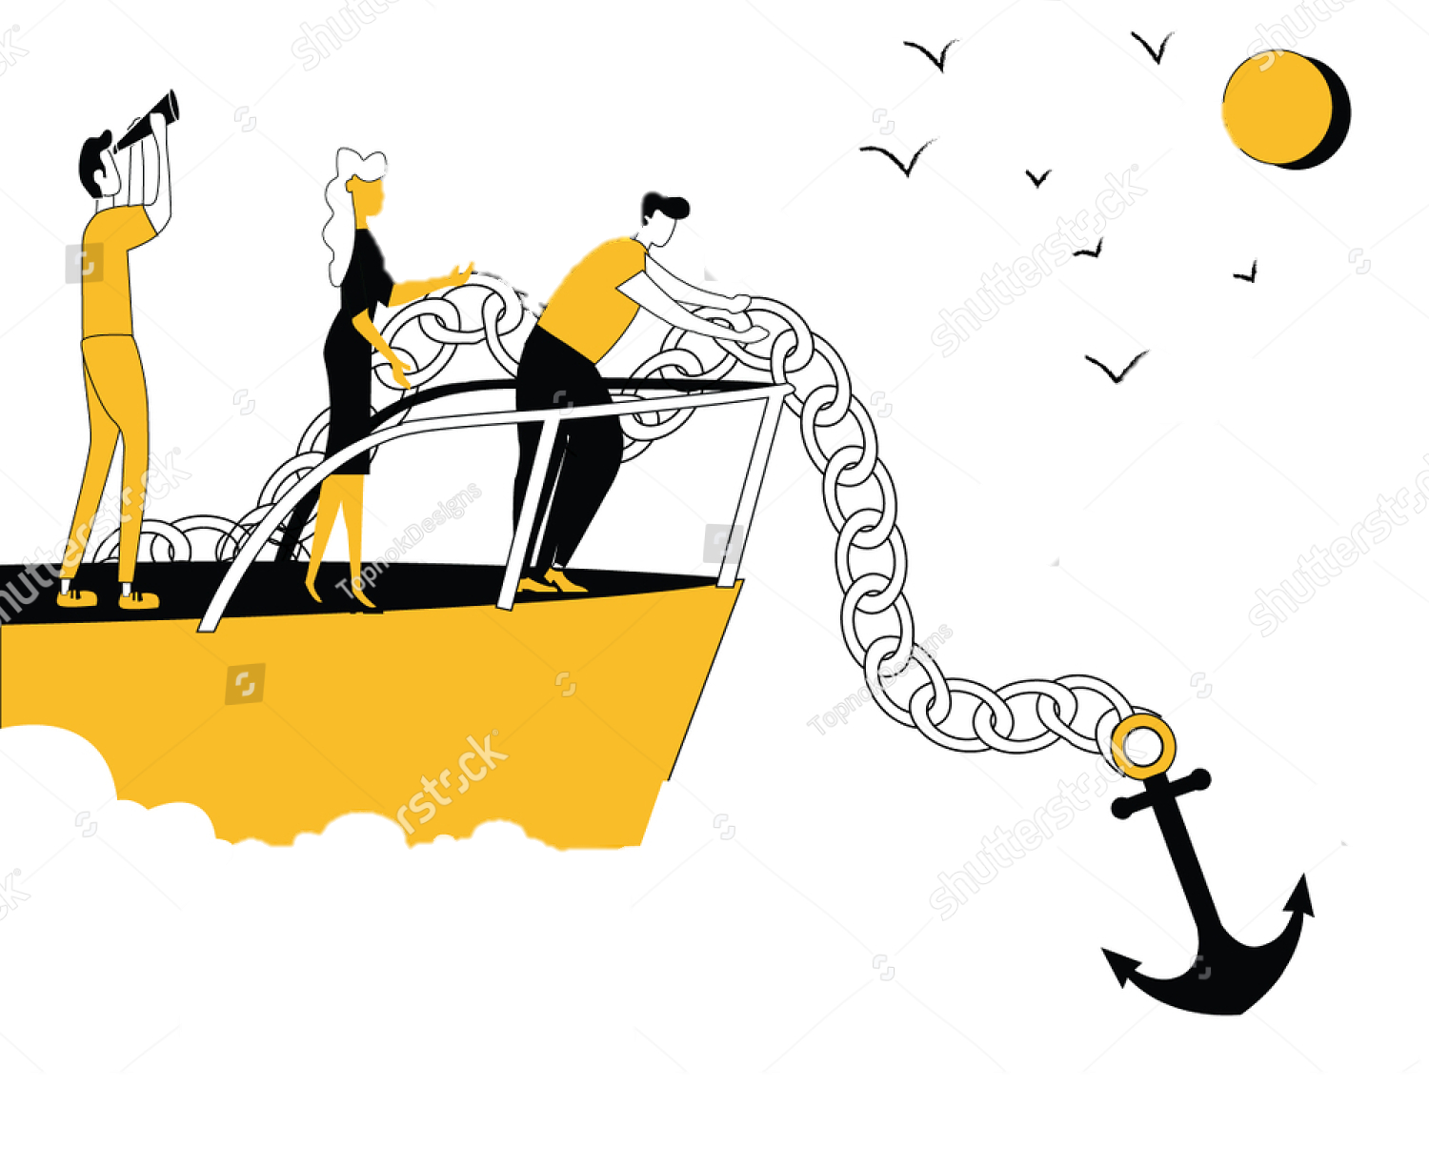

Similarly, in an ongoing crisis, we experience emotional storms. This might be unhelpful thoughts spinning in our heads, and painful feelings whiling around our body. And if we’re swept away by the storm inside us, there’s nothing affective we can do. So how can we ‘drop anchor?’

- Acknowledge your thoughts and feelings
Silently and kindly acknowledge whatever thoughts, feelings, emotions, memories, sensations or urges you may have. Observe what is happening in your inner world.

- Come back into your body
Try to connect with your physical body. You could try:

- Slowly pushing your feet hard to the floor
- Slowly straightening your back and spine
- Slowly pressing your fingertips together
- Slowly stretching your arms or neck
- Focus on your breathing

- Engage in what you’re doing
Refocus your attention on the activity you are doing. You could try
- Looking around the room and noticing 5 things you can see
- Notice 3 or 4 things you can hear
- Notice what you can smell or taste or sense in your nose and mouth
- Notice what you are doing

Run through these 3 steps 3 or 4 times, to turn it into a 2-3 minute exercise. This can help you ground and steady yourself if you are feeling worried or anxious.
Dealing with difficult emotions
Feelings such as fear, anxiety, anger, sadness, guilt, loneliness, frustration, and confusion are bound to show up when a crisis unfolds. It can be helpful to keep a journal to help process your thoughts and feelings. It’s also important to be kind to yourself and recognize everyone has good days and bad days in times of uncertainty.

It can be helpful to think ‘if I wanted to be kind and caring to someone I loved, how would I treat them? How would I behave towards them? What might I say or do?’ then try treating yourself in the same way.

Difficult emotions may arise for lots of reasons. In particular not being able to engage in your usual activities for prolonged periods of time can impact mood. It’s important to acknowledge progress and focus on small achievements to help foster a sense of competence.

With a lot of uncertainty it is also important to focus on the positives. To help manage your mood it can be useful to set aside time to think about 2 or 3 positive things that have happened each day.

Adjusting
The current situation with COVID-19 means that everyone will need to make adjustments such as spending more time at home or asking others for support. It takes us all time to adjust to new situations (usually around 10 days).

We can help ourselves adjust by:
- Focusing on the future and realize that things will gradually improve and conditions will normalize.
- Establish a routine to facilitate a sense of control and reduce uncertainty by building a constant in each day. (You may find it helpful to use the activity schedule on page 8 to help build a new routine).

Reducing monotony and boredom
Spending more time indoors can foster a sense of boredom. It is important to add variety to your day. You could try to engage in creative activities or hobbies such as reading, listening to music, playing
card games, cooking or meditation. There are some further ideas on meaningful activities on page 9. Engaging in meaningful activities can help create a sense of purpose, reduce boredom and improve mood.

Seeking help
Identify resources for help, assistance, support and advice. This might be friends, family, health professionals and emergency services. Reach out to your social networks, and if you can offer support to others let them know. Check with local supermarkets about allocated opening times for vulnerable and elderly customers.

Reducing conflict
If you are self-isolating it can be difficult to spend prolonged periods of time isolated with others. To help reduce conflict, it can be useful to:
- Have a designated area of personal space to retreat to if you need some space.
- Have honest conversations together about things that are causing you irritation or frustration.
- Establish ground rules.

Coping with separation
It can be lonely if you have to self-isolate and are separated from friends or family. Try to:
- Stay in touch with others through messages, telephone calls or video calls.
- Join an online peer support group (Mind runs an online peer support community called Elefriends).
- Put up extra picture of the people you care about to have a nice reminder of the people in your life.

Feeling claustrophobic or trapped
Spending prolonged times indoors can be difficult if you are feeling trapped. Try to:
- Open the windows to let in fresh air.
- Spend time sitting on your doorstep, or the garden if you have one.
- Try looking at the sky out of the window or from your doorstep.
- Regularly change the rooms you spend time in.

Being prepared
There are certain practical things you can do to make sure you are prepared during this time of uncertainty. Some ideas are:
- Make sure you have access to a good stock of any medications you may need (up to 2 weeks is recommended). This may mean asking for assistance from a friend or family member to get access to this.
- Ensure you have a way to get food shopping safely, or have access to a good stock of food. This may mean getting help from a friend or family member, or getting support from a community resource.
- Eat well and stay hydrated
- Continue accessing essential treatment where possible (this may be over the phone).
- Get as much sunlight, fresh air and nature as you can (this may be in the garden, opening a window for fresh air, growing plants indoors).

Keeping informed about COVID-19 With a lot of information being circulated daily about COVID-19, it can be overwhelming, scary and difficult to know which information to trust. You can help manage this by:
- Making sure the information you are looking at is from a trustworthy source (such as the NHS website or World Health Organisation).
- Reduce watching or listening to news that makes you feel worried or distressed.
- Set a specific time each day to update yourself with the most recent information to reduce the near constant stream of information that could make you feel worried.

Support from mental health services at Oxleas

Although some changes have been made to community mental health services at Oxleas to prevent the spread of COVID-19, you can still access support by:
- Contacting your care coordinator
- Accessing psychological support via phone consultations
- If you are experiencing a crisis contact your care coordination or use the crisis line on 0800 330 8590.

The following pages contain some helpful resources you may find useful during this time of uncertainty.

Activity Schedule- Use the activity schedule below to help plan your week.
 | Monday | Tuesday | Wednesday | Thursday | Friday | Saturday | Sunday
Morning
Afternoon
Evening

Activity Menu

Animals  Pet an animal  Walk a dog  Watch for birds and wildlife outside  Listen to the birds  Watch a wildlife documentary | Cook  Cook a meal for yourself or others  Bake a cake  Find a new recipe | Mind  Meditate  Pray  Reflect  Mindfulness exercise  Relaxation exercises  Yoga | Self Care  Take a bath  Take a shower  Wash your hair  Give yourself a facial  Trim your nails  Take a nap  Massage your hands
Create  Draw a picture  Paint a portrait  Take a photograph  Doodle/ sketch  Organize photographs  Make a photo album  Start a scrapbook  Do knitting or sewing  Start a project  Make something | Music  Listen to music you enjoy  Find some new music to listen to  Listen to the radio  Make some music  Sing a song  Play an instrument | Clean  Clean the house  Clean a room in the house  Do laundry  Do some chores  Organize a space  Clear out a cupboard | Nature  Do some gardening  Grow some plants indoors  Do some pruning  Mow the lawn  Pick flowers  Spend time in the garden or near an open window
Exercise  Do some armchair exercises  Do some yoga  Go for a walk in the home or garden  Do a workout video | Plan  Set a goal  Think of things you would like to do in the future that you cant do now  Make a to do list | Learn  Learn a new language  Learn a new skill  Enroll on an online course  Read a new book | Connect with people  Contact a friend or family member  Contact someone vie video message  Write a letter to someone
Relaxed Breathing

When we are anxious or threatened our breathing speeds up in order to get our body ready for danger. Relaxed breathing can help tell the body that it is safe to relax. Relaxed breathing is slower and deeper than normal breathing and it happens in the belly rather than the chest.

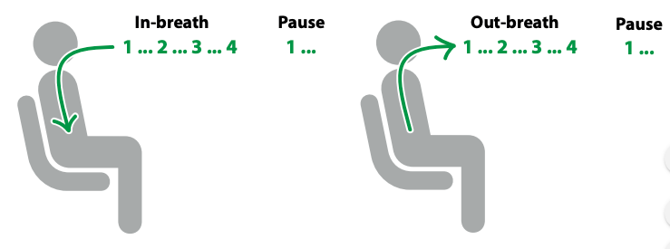

- Make sure you are sitting or lying comfortably
- Close your eyes if it is comfortable to do so
- Try to breathe through your nose rather than your mouth
- Deliberately slow your breath down. Breathe in to the count of 4, pause for a moment, then breathe out to a count of 4
- Make sure your breaths are smooth, steady and continuous
- Pay particular attention to your out breath

Tips:
- Try to feel your breath in your belly, not your chest
- It can be helpful to put a hand on your belly to do this
- Try doing this for a few minutes time around 5-10 minutes
- Try to practice regularly

Simple Mindfulness Exercises
Mindfulness means paying attention to what is happening to your inner world. It is easy to get caught up in worrying thoughts and feelings. Mindfulness can help refocus our attention on the present.

 | 1. | Body Scan  Close your eyes and take some time to bring detailed awareness to each part of the body. Start with your toes, then your feet, then your ankles, then your legs and so on until you get to your head. Focus on the sensations you can feel at each stop.
 | 2. | Mindful eating  Take a raisin or something else small and edible in your hand and spend some time observing it. Observe it as though you have never seen one before. Notice the shape and colour. Then, when you’re ready smell it, and notice what it smells like, before placing it in your mouth and noticing what it feels like. Move it around in your mouth and notice what happens, before biting it and noticing the flavor. Take your time with this exercise.
 | 3. | Mindful Breathing  Close your eyes and bring your attention to your breath, and where you feel it most. It might be at the tip of your nose, or in your chest, or maybe in your belly. Spend 5 minutes or so being curious about the breath.
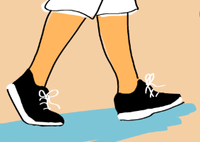 | 4. | Mindful Movement  Take some time doing something active, maybe walking slowly or stretching. When you are doing this, pay particular attention to the sensations in the body. What does it feel like to walk or move in that way?
Activities pages- Mindful Colouring

Activity Pages- Crosswords

Across  1 Waggish (4)  3 Loyal (8)  9 At ease (7)  10 Domain (5)  11 Dry Spanish wine (5)  12 Receding (6)  14 More corpulent (6)  16 Stableman at an inn (6)  19 Remember (6)  21 Labyrinths (5)  24 Minimum (5)  25 Quiver (7)  26 Seductive (8)  27 Homer Simpson's son (4) | Down  1 Planes (8)  2 String quartet member (5)  4 Patron saint of Scotland (6)  5 Pulsate (5)  6 Face-cloth (7)  7 Floppy (4)  8 Breathe out (6)  13 Outlook (8)  15 Elation (anagram) (7)  17 Boil slowly (6)  18 Protein present in wheat (6)  20 Later on (5)  22 Striped animal (5)  23 Supplication (4)

Across  1 Egyptian monument (7)  5 Vagrant (5)  8 Governed (5)  9 Large ape (7)  10 Slope (7)  11 Use a divining-rod (5)  12 Depart (2,4)  14 Frankfurter in a bun (3,3)  18 Drink in large draughts (5)  20 Changed (7)  22 "___ Grace", popular hymn (7)  23 Ground meat (5)  24 Devoured (5)  25 Wavy, winding (7) | Down  1 Sounding pleased (like a cat) (7)  2 Historical memento (5)  3 Fortified white wine (7)  4 Knife for stabbing (6)  5 Weary (5)  6 Permitted (7)  7 Situation (5)  13 Stubbornly unyielding (7)  15 Low stuffed seat (7)  16 Female deity (7)  17 Canal boats (6)  18 Tremble (5)  19 Pretend (5)  21 Beatles drummer (5)

Activities- Sudoku
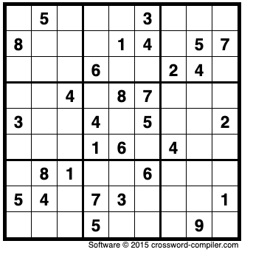
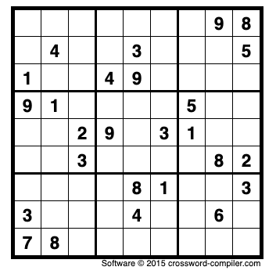

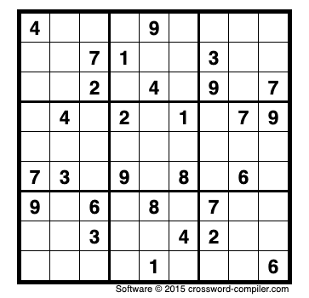
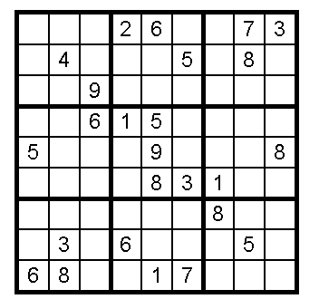

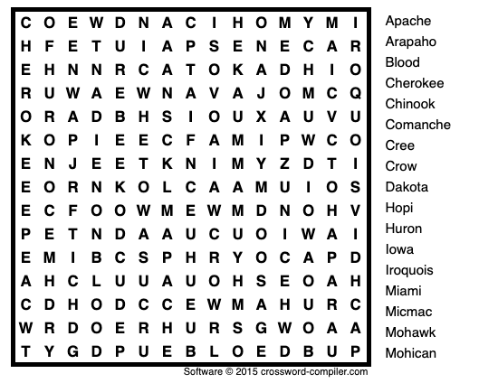
Activities- Word Search
