Handwritten Letters
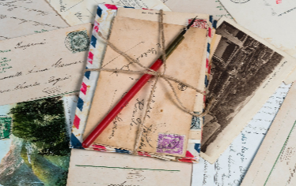

The Handwritten Letter Appreciation Society is a way to bring together people who love to write and receive handwritten letters, and to stop them from becoming a lost art. It aims to:
- Inspire people to write handwritten letters to each other.
- Unite letter writers in a bid to boldly cling on to the dying art of writing letters.
- Put the fun and meaning back into writing letters.
- Value the beauty of an individual’s handwriting.
- Encourage anyone and everyone to put pen to paper and send a letter to someone special.
- Gather together everything to do with handwritten letters in one place.
http://thehandwrittenletterappreciationsociety.org/

BBC Podcast
Listen to this podcast by author Helen Cullen, who makes the case for the art of letter writing and its value to us as humans https://www.bbc.co.uk/sounds/play/m00088jb

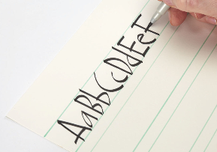
Other Articles
The Value of the Handwritten Letter here
10 Reasons why you should write more handwritten letters here
How to improve your handwriting style (adults) here
Lettering – different and creative styles of writing here

