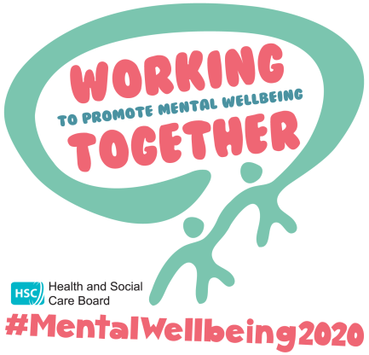
Free Online Training to Support Your Mental Health

Zero Suicide Alliance Training
Zero Suicide Alliance offers a free ‘3 step’ awareness training programme which provides a better understanding of the signs to look out for and the skills required to approach someone who is struggling, whether that be through social isolation or suicidal thoughts.
Click here to take the course
SHSCT Staff complete the course through by logging onto: https://www.hsclearning.com

Psychological First Aid
Psychological first aid is a simple, yet powerful way of helping someone in distress during and after a crisis like the COVID 19 pandemic. It involves paying attention to the person’s reactions, active listening and if relevant, practical assistance to help address immediate problems and basic needs.
Click here to take the course

Stress Control
The PHA funds free Stress Control programmes that teach skills and techniques for managing stress. Topics covered include what stress is, controlling your body, controlling your thoughts, controlling your actions, managing panicky feelings, getting a good night’s sleep and planning for the future.
Click here to take the course

Living Life to the Full
This is a six week programme using a CBT approach. It introduces participants to the ‘Five Areas Approach’ which illustrates that events and situations in our lives affect how we think, how we feel, how we behave and also affect us physically. This programme is funded by SHSCT and is therefore free to participants.
Click the following link to register for a place: https://www.aware-ni.org/booking-living-life-to-the-full/

Mood Matters
This is a mental health awareness programme particularly for those who may be experiencing low mood, stress or mild to moderate depression. Duration 2 hours. This programme is funded by SHSCT and is therefore free to participants.
Click the following link to register for a place: https://www.aware-ni.org/booking-mood-matters-adults/

Online webinar WSPD - Creating Trauma Sensitive Suicide Prevention Practice – facilitated by Orla Murtagh Protect Life Coordinator 1030 am- 1130am - 10th September 2020
For practitioners working to support positive mental health - Overview of NI Protect Life strategy, theoretical models relating to the complexity of suicide, unresolved trauma and loss as it relates to suicide, why compassion, creating safety and self care matters, sources of help and support. To book a place please email: Karen.mccabe@southerntrust.hscni.net before: Monday 7th September 2020 with name, email and work role details. Places are limited.

Online webinar. Supporting those who internalise their distress. Facilitated by Jan Montgomery, Psychotherapist - 29th September 2020 – 10- 11.30am
During this webinar we will be exploring why some individuals internalise their distress. We will learn how this might mean that their distress is missed or dismissed. This webinar is designed to be useful for anyone who knows, works with or lives with someone who internalises their distress – age not important. We will think about how best to build relationships with these individuals and think about how we can enable them to express their emotions without feeling exposed or highly vulnerable. To book a place please email: pwb.training@southerntrust.hscni.net before : Thursday 24th September.

Take 5 Online – Facilitated by SHSCT Promoting Wellbeing Support Workers, 4 week programme beginning Monday 19th October 2020, 12noon – 1.00pm
This interactive programme is aimed at creating awareness of the Take 5 Steps to Wellbeing concept. It will help support us embed Take 5 in our daily lives. To book a place please email: pwb.events@southerntrust.hscni.net before 9th October 2020

The Protect Life Resource Service
(Southern Area, a partnership between PIPs Hope & Support and AMH MensSana) continue to support you and your community with a rolling training programme of mental health promotion, suicide and self-harm prevention tailored to suit individual and group needs. Training is agreed with beneficiaries, stepped to promote progressive learning as appropriate. Training can include Mental Health First Aid, Healthy Me, Shoulder-2-Shoulder, Provoking Thought and Gimme5.
For more information please contact:
menssana@amh.org.uk
info@pipshopeandsupport.org

The Recovery and Wellness College
There is a recovery college in each Trust are that offers free courses and workshops that support people to better understand and manage their mental health and wellbeing. All courses are written and delivered by people with lied experience of mental health issues in partnership with those who have professional experience and knowledge. The free courses are open to everyone who is interested in good mental health.
For more information about the Southern Trust Recovery College click here

