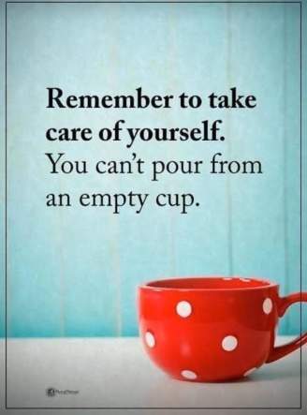
Consequences of not practicing self-care:
- Low energy
- Feeling hopeless
- Less patience
- Increased headaches, stomach aches, and other physical symptoms of stress
- Difficulty falling and staying asleep
- Challenges in choosing healthy food and urges to eat “comfort” foods
- Worsening mental health symptoms like depression or anxiety
- Feeling “burnout”
- Difficulty concentrating
- Strain or distancing in the relationship with your spouse or partner
- Less patience with your children
- Reduced performance at work
- Less motivation to engage in social activities.
For more information on self-care and compassion visit Umatter.

