Leftover lamb curry
Easy
Serves 4-6
Prep: 10 mins
Cook: 1hr 30 mins

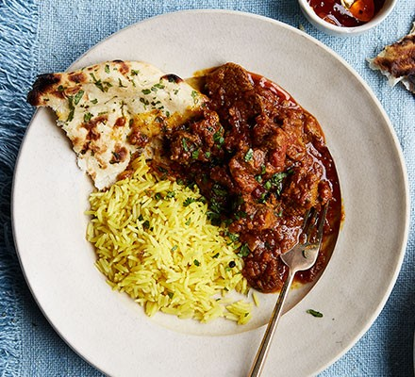
Nutrition: per serving (6)
kcal  393 | fat  24g | salt  0.6g | sugar  6g

Ingredients  2 onions  1 large garlic clove,  1 thumb sized piece ginger  2 tbsp oil  4 tbsp medium curry paste  400g can chopped tomatoes  1 red chilli  1 cinnamon stick  200ml lamb/veg stock cube dissolved in water  (can use leftover stock - cool in fridge and then remove layer of hard white lard before use)  500-700g leftover roast lamb  1 small bunch of coriander | What you will need:  Food processor  Casserole dish
Method
- Whizz the onion, garlic, ginger and 200ml water in a food processor until you have a smooth paste.
- Heat the oil in a casserole dish and fry the onion mixture for 10-15 mins or until all the liquid has been absorbed and the onion begin to turn golden brown.
- Add the curry paste and fry for 1 min more.
- Stir through the tomatoes, cinnamon and chilli.
- Pour in the stock and bring to a simmer.
- Add the lamb and cook, covered for 1 hr.
- Remove the lid and simmer uncovered for 15 mins to reduce slightly.
- Season to taste and stir through the coriander.
- Serve with fluffy basmati rice, naan bread and yogurt.

