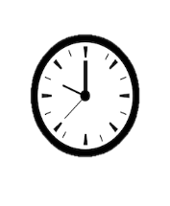
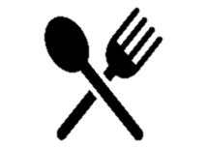
Medium
Serves 25
Prep: 90 mins
Cook: 15 mins
Hot Cross buns
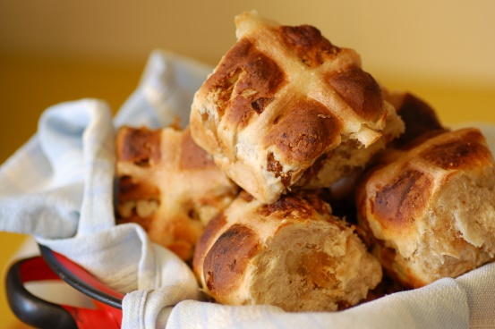
Nutrition: per serving (25)
kcal  202 | fat  1.9g | salt  0.24g | sugar  14g

Ingredients:
Dough:  14g active dry yeast  100ml water  200ml semi-skimmed milk  100g sugar  57g softened margarine  1 teaspoon of vanilla essence  1 teaspoon of salt  ½ teaspoon freshly ground nutmeg  850g all-purpose flour  4 medium eggs  75g sultanas  75g raisins | Glaze:  2 tablespoons of water  1 medium egg yolk | Icing:  130g icing sugar  4 teaspoons of water  ¼ teaspoon of vanilla essence  Pinch of salt, to taste
 | What you will need: Baking tray, Chopping knife, Kitchen scales, Mixing bowl, Saucepan, Whisk
Methods:
Dough:
- Warm the water and milk in microwave/saucepan - warm to touch, not hot.
- In mixing bowl, dissolve yeast in the warm water and milk. Add in sugar, butter, vanilla, salt, nutmeg, and half the flour. Beat until smooth
- Mix eggs in a separate bowl then add them into the blend
- Stir in the raisins and sultanas and enough of the remaining flour to make the dough soft
- Turn dough onto floured surface and knead until the dough is smooth.
- Place in a greased bowl and flip the dough over once to grease both the top and bottom
- Cover with a damp towel and leave in warm place for an hour or until doubled in size
- Knead dough down and shape into 25 balls. Place on lightly greased baking sheets
- Cover and leave to rise for another 30 minutes or until doubled
- Using a sharp knife, score a cross on the top of each roll
- Beat the water and egg yolk together and brush over the rolls
- Bake at 190°C for 12 to 15 minutes. Then cool on wire rack for 15 to 20 minutes
Icing:
- Combine the icing ingredients in a medium-sized bowl
- Stir until smooth, adjusting sugar and water to form a smooth consistency that flows easily
- Drizzle icing over the top of each roll, following along the lines of the cut cross

